Screenshots

Dashboard Page
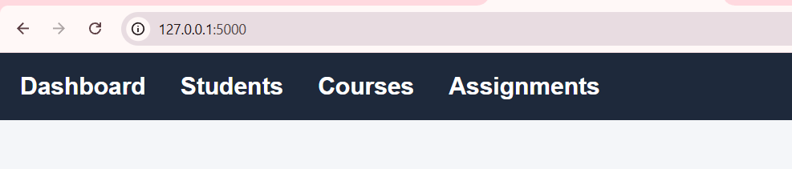
Student Module
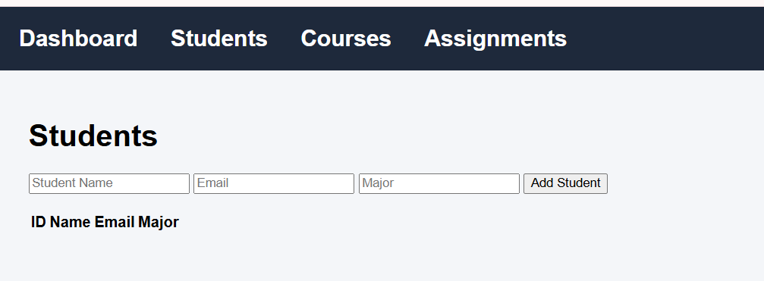
Course Module
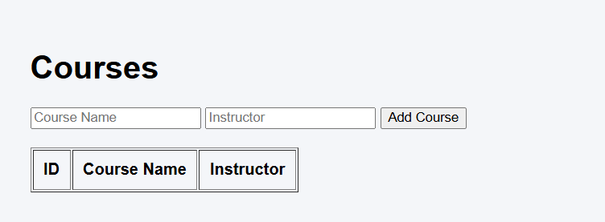
Assignment Module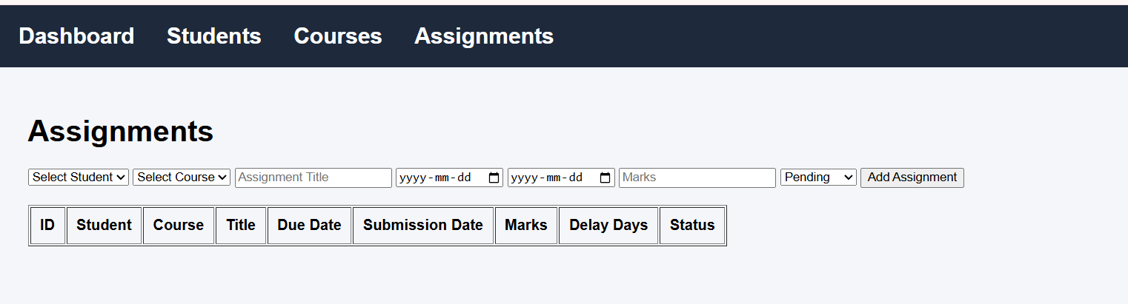
ADDING SAMPLE DATA

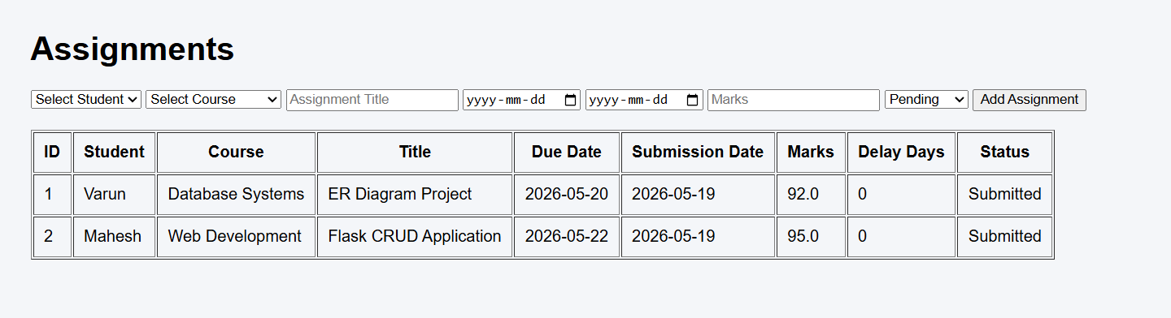
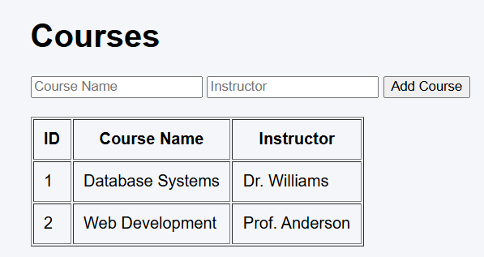
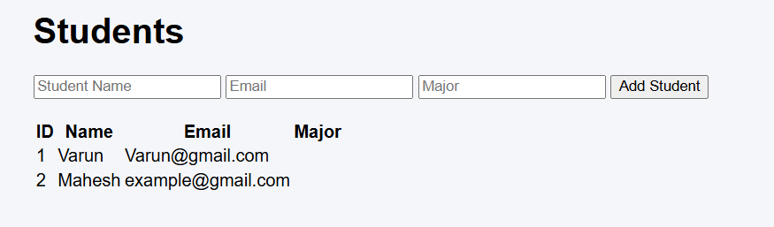

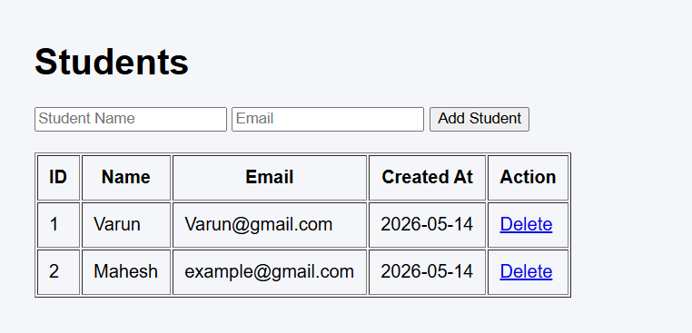
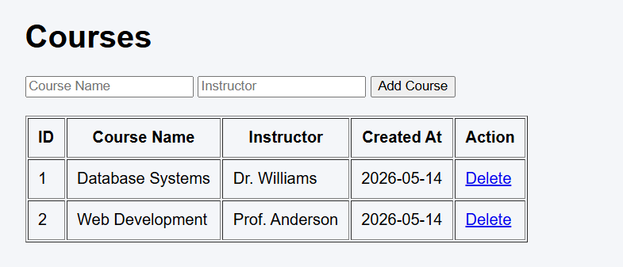
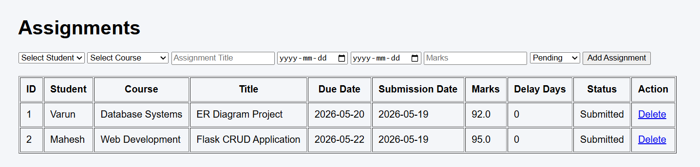

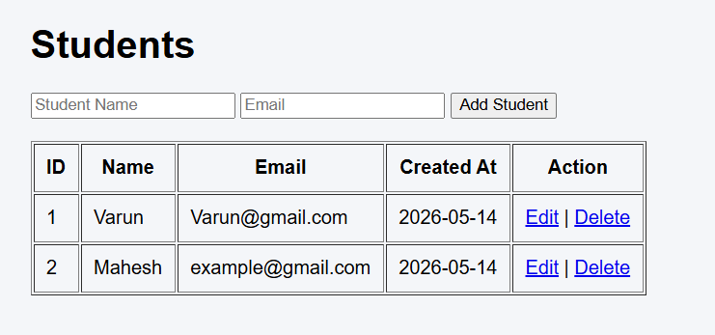
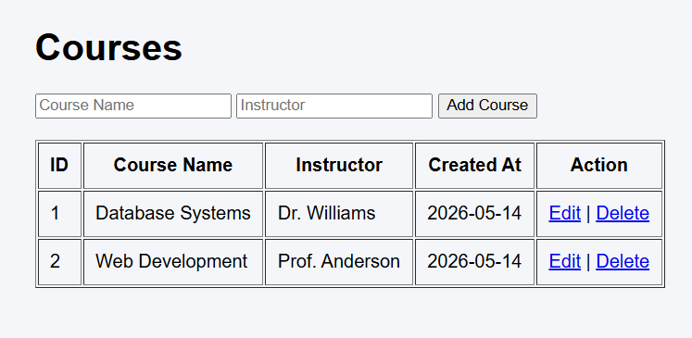

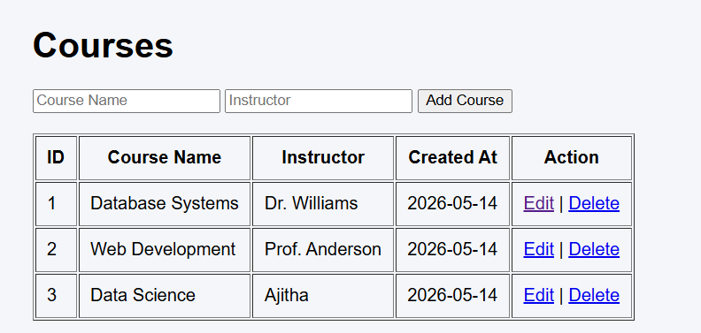

Applied Delete option

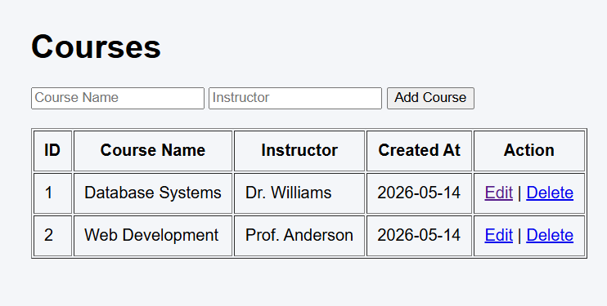

Git commands:-

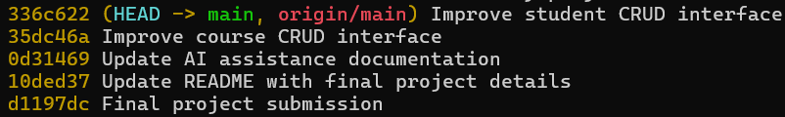

Links: -

https://github.com/FaridKumarReddyKattekommula/Student-Assignment-Tracker-System?utm_source=chatgpt.com
alternative: -
https://github.com/FaridKumarReddyKattekommula/Student-Assignment-Tracker-System
dashboard link: -
http://127.0.0.1:5000/

